1. Java does not have a built-in Date class, but we can import the java.time package to work with the date and time API. The package includes many date and time classes. For example:

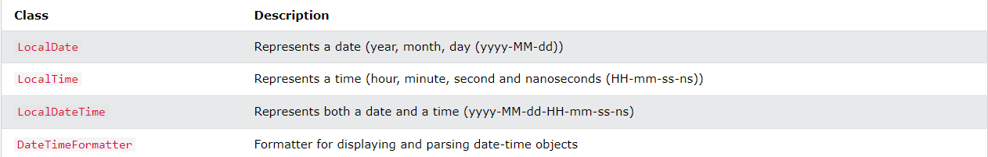

1. 